Following Christ and Being His Beacon in Our Community
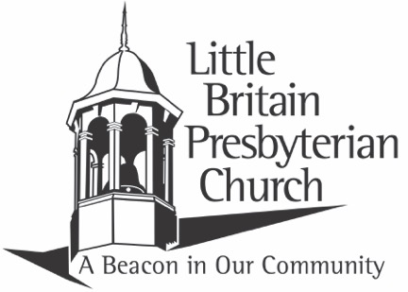

GOOD FRIDAY TENEBRAE SERVICE
Friday, April 18, 2025 7:00 p.m.
Welcome
The Palms Mark 11:1-11 Pastor Tom Milligan
Greeting Pastor Tom Milligan
Leader: Praise the Lord, you who are God’s servants!
People: Praise the name of the Lord. May God’s name be blessed from now on and forever.
Leader: Wherever the sun shines, from dawn until dusk, let God’s name be praised.
People: Praise the Lord!
* Hymn (Praise & Worship): “The Power of the Cross” #100
* Opening Prayer & The Lord’s Prayer
Our Father, who art in heaven, hallowed be thy name thy kingdom come thy will be done on earth as it is in heaven. Give us this day our daily bread and forgive us our debts as we forgive our debtors, and lead us not into temptation but deliver us from evil, for thine is the kingdom and the power and the glory forever. Amen.
Scripture: John 14: 1-11 Pastor John Barlow

Meditation: Benefits of Jesus’ Departure Pastor John Barlow
Choir Anthems: “When You Prayed Beneath the Trees”
“Within the Shadow of the Cross”
THE UPPER ROOM
The Upper Room: Mark 14: 22-25 Pastor Jeremy Peterson
Invitation to the Table Pastor Jeremy Peterson
*Hymn: “Let Us Break Bread Together” #323
Prayers for Bread and Cup
Breaking of the Bread
Communion
All who have placed their faith in Jesus as Savior and Lord are welcome to receive the gifts of bread and cup from Christ’s table.
The Shadows
The Shadow of Denial: Mark 14: 26-31 Rose Griest
*Hymn: “See the Destined Day Arise” (insert)
The Shadow of Sorrow: Mark 14: 32-42 Kevin Oswald
The Shadow of Betrayal: Mark 14: 43-45 Sandra Armstrong
*Hymn: “Were You There?” (vs. 1,2,3) #181
The Shadow of Desertion: Mark 14: 46-52 Patty Brown
The Shadow of Trial: Mark 14:53 – 15:15 Dan Henry
The Shadow of Crucifixion: Mark 15: 16-32 Vicki Graybeal
The Shadow of Death: Mark 15: 33-47 Jerry Phillips
Silent Reflection
Looking Forward: The Return of the Light of Hope
Blessing
All Depart in Silence
The offering tonight will be collected in offering boxes as you leave. It will be given to Water Street Mission.

The service of Tenebrae:
The ancient Tenebrae service is to recreate the emotional aspects of the passion story of Jesus Christ. The word Tenebrae means shadows, and throughout the service the sanctuary will become gradually darker.

Thank you to everyone who helped make tonight’s service possible.

Today is a remembrance of Christ’s crucifixion. Sunday is a day of victorious celebration of Christ’s resurrection.

Contact Information
255 Little Britain Church Road, Peach Bottom, PA 17563
Telephone: 717-548-2266
Email: lbpc1732@gmail.com
Visit us on the web at: www.littlebritainchurch.org

